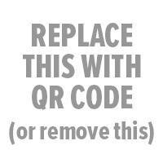

School Name Yearbook
Where: | store.shopyearbook.com/enter-path-to-store
Price: | enter a price or prices
Order By: | enter deadline date

First 4 Personalized Pages: | $5.00 | Order your yearbooks online at the above web address. Then, login before the deadline to design and “finalize” your personalized pages.
Additional 8 Pages: | $1.50 / ea.
“Finalize” By: | enter deadline

