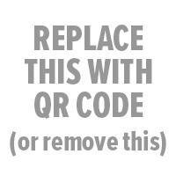

School Name Yearbook
Online: | store.shopyearbook.com/enter-path-to-store
Price: | enter a price or prices
Order By: | enter deadline date

Order online at the address above OR fill out and return the form below:

School Name Yearbook Order Form

Student Name:  Grade:  Homeroom:  Parent Email:  Today’s Date:  Check #: | ORDER SUMMARY:  Qty Qty x Price  Hardcover Yearbook $  Softcover Yearbook $  Order Total: $  Return order form with your payment to <insert info>.  Make checks payable to <insert info>.

