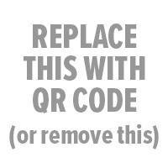

School Name Yearbook

Where: | store.shopyearbook.com/enter-path-to-store
Price: | enter a price or prices
Order By: | enter deadline date

How to Order Your Yearbook:
1. Go to the web address above. You can order from a computer or a mobile device.  2. Click Select + under this year’s yearbook.  3. If you don’t have an account, create one by clicking Sign Up.  4. Enter the name of your student or students if you are ordering for more than one. Click Continue.  5. For each student, select a product and quantity. Click Continue. | 6. Enter your payment information. You can pay with PayPal or with a credit card.  7. Click Place Order.  8. Make sure you see a Thank You page confirming your order has completed.

